COMSATS University Islamabad

## Abbottabad Campus

**Assignment no 1**

**Submitted by:**

**Syed Hussain Mustafa (SP22-BSE-159)**

**Subject:**

**Human Resources Management**

**Submitted to:**

**Sir Muhmmad Fayyaz Sheikh**

**Date: 08/11/2024**

**Question no 01:**

write the time stamp when he is presenting?

**Code:**

import java.text.SimpleDateFormat;

import java.util.Date;

public class TimeDisplay {

public static void main(String[] args) {

SimpleDateFormat sdf = new SimpleDateFormat("HH:mm:ss");

try {

while (true) {

String currentTime = sdf.format(new Date());

System.out.print("\rCurrent Time: " + currentTime);

Thread.sleep(1000);

}

} catch (InterruptedException e) {

System.out.println("\nTimer stopped.");

}

}

}

**Usecase Diagram:**

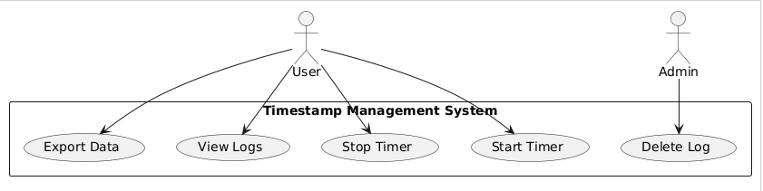

**Communication diagram:**

